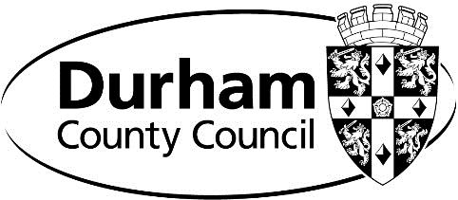

Durham County Council

Oakenshaw Neighbourhood Plan

Basic Conditions Decision Statement
[Town and Country Planning England (Referendums) Regulations 2012 Reg. 4 - Paragraph
1A.]

Durham County Council has considered the Report of the Independent Examination into the Submission Draft Oakenshaw Neighbourhood Development Plan dated 3rd August 2020 and is satisfied that, subject to the inclusion of the modifications recommended by the examiner, the Plan meets the Basic Conditions as set out in paragraph 8(2) of Schedule 4B to the Town and Country Planning Act 1990. The Plan complies with the provision made by or under sections 38A and 38B of the Planning and Compulsory Purchase Act 2004.

Stuart Timmiss (Head of Development & Housing)
Dated: 18 December 2020

