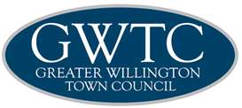

COMMUNITY ENGAGEMENT
- STATEMENT OF INTENT

Approved by members on:..................................................................14th May 2019
Due for review............................................................................................May 2020

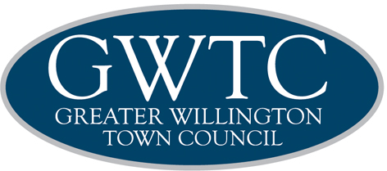

GREATER WILLINGTON TOWN COUNCIL
COMMUNITY ENGAGEMENT - STATEMENT OF INTENT

Introduction

Greater Willington Town Council is committed to improving our engagement with all sections of the local community: residents, voluntary groups, young and elderly, businesses and local groups and organisations. The overall aim is to increase the involvement of people in the life of their communities and in the Council's decision making processes. In doing this the Council will become more responsive to the needs of the Community and be able to better reflect its views and aspirations.

Engagement

Greater Willington Town Council intends to actively engage with the following sections of the community:

- Residents of the parish
- Local youth groups
- Groups representing the elderly
- Residents Associations
- Voluntary Organisations
- Community Associations
- Schools
- Businesses within the Parish
- Church Groups
- Councillors - public service representatives and staff

Effective engagement can only be achieved through providing information to these sectors and seeking resident’s views. The Council already employs a number of methods to do this:

- Contact details of the Council Offices and staff and individual Councillors are available in the Council's quarterly newsletter and on the Council's website.
- The Newsletter informs the community of the activities of the Council, and is made available at public venues throughout the Parish.
- Notices of meetings are posted on the Council's notice boards and on its website.
- The notices indicate that the Council gives the public the opportunity to participate in meetings. The Council's policy on public participation is available on its website and at the Town Council offices.
- The Council's website provides details of its services and activities and provides access to the Council minutes and number of documents.
- The Council publishes an Annual Report which is made available at public places throughout the Town. A summary of the report is outlined in the Council's newsletter.
- Representatives of the Council attend local voluntary organisations and some Councillors are members of these voluntary organisations in their own right.

Aims and Objectives

The Council's aims and objectives for seeking community engagement and the outcomes it hopes to achieve are:

- To enable an involved and active community through consultation with residents on local issues, reaching all sectors of the community including hard to reach groups, and seeking the views of young people.
- To communicate information clearly and factually through the management of the Council's website and the publication of a quarterly newsletter.
- To improve communication with partner organisations
- To actively be involved in local organisations such as Residents organisations, youth groups and community groups.
- To raise the profile and reputation of the Council through
- Inviting residents to take part in council meetings through public participation.
- Publicising the Annual Town meeting throughout the Parish area.
- Informing the press of the activities of the Council, when appropriate.
- Encouraging the Chairman to fulfil his civic role by accepting invitations to community events.
- To enable each Councillor to effectively perform their role as elected representatives of the community through
- The issue of a new members information pack
- Encouraging Councillors to attend meetings of community organisations or take up places on community groups and organisations.
- To ensure Town Council staff represent the interest of the Council at community events
- To encourage staff to have an effective input into the Council's decision making process.

ACTION PLAN FOR EFFECTIVE COMMMUNITY
ENGAGEMENT

Minutes | Ensure copies of minutes are available in hard copy and on the website and that copies are sent to relevant Unitary Councillors | Staff | Ongoing
Notice of Meeting | Ensure notice is posted on Council Notice Boards, and local meeting points | Staff | Ongoing
Annual Report | Ensure report is available in hard copy and  on website. Copies to be distributed to  public places throughout Town and to the  Unitary Authority | Staff | Annually
Office opening hours | Publicise on notice boards, website and in  newsletters | Staff | Ongoing
Annual parish meeting | Publicise throughout town | Staff | Annually
Public participation | Publicise Councils policy on public  participation on website and on notice boards | Staff/members | Monthly
Website | Maintain website with information on  Council functions and activities | Staff | Ongoing
Newsletter | Produce and distribute half yearly newsletter | Staff | Half Yearly
Youth groups | Maintain contact with local schools and  youth groups | Staff/members | Ongoing
Local groups and organisations | Maintain contact through local  representatives and attendance at meetings or events work together with the local Partnership | Staff/members | Ongoing
Press | Inform press of councils activities and meetings | Staff | Ongoing
Unitary authority | Maintain contact with local members and  Unitary Authority staff to ensure sharing of  information | Staff and members | Ongoing

