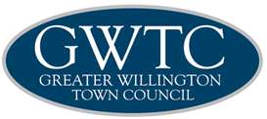

DIVERSITY STATEMENT

Approved by members on:..................................................................14th May 2019
Due for review............................................................................................May 2020

DIVERSITY STATEMENT

Greater Willington Town Council celebrates diversity and the strength it brings to our community and wider society. Prejudice connected to disability, gender, ageism, racism, xenophobia, homophobia, religious intolerance and hate crimes have no place in our town.

Greater Willington Town Council condemns all such intolerance and hate crimes unequivocally and they will not be tolerated.

All people living in the Greater Willington area are valued members of our community.

Diversity and unity are strength.

